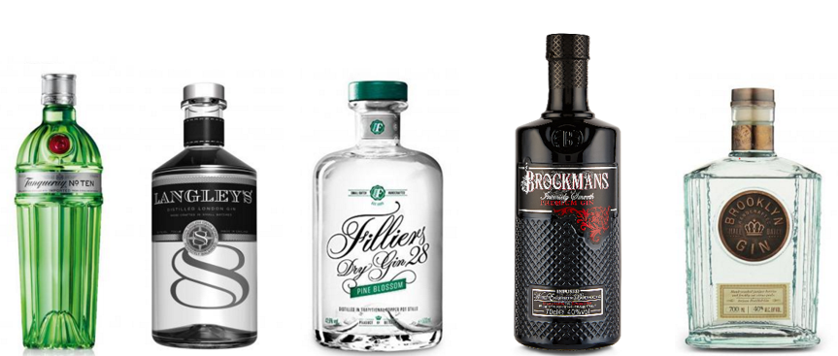
Gins Now Available and in Stock

QUANTITY | PRODUCT | PRICE | CATEGORY
2 | 6 O’clock Gin 70cl | £23.00 | Gin
2 | Alkkemist Gin 70cl | £29.00 | Gin
1 | Akori Premium Gin 70cl | £25.00 | Gin
2 | Batch, Gin 70cl | £24.00 | Gin
2 | Bathtub Gin 70cl | £23.00 | Gin
1 | Beefeater 24 Gin 70cl | £20.00 | Gin
1 | Berliner Brandstifter Dry Gin 70cl | £32.00 | Gin
1 | Blind Tiger Imperial Secrets Gin 50cl | £26.00 | Gin
2 | Boe Violet Gin 70cl | £19.00 | Gin
1 | Boxer Gin 70cl | £22.50 | Gin
1 | Broken Heart Gin 70cl | £35.00 | Gin
1 | Burleighs - Pink, Gin 70cl | £33.00 | Gin
1 | Burleighs - Signature, Gin 70cl | £20.00 | Gin
1 | Caorunn, Gin 70cl | £21.00 | Gin
1 | Colonel Fox, London Dry 70cl | £17.00 | Gin
1 | Copperhead, Gin 50cl | £29.00 | Gin
2 | Cream Gin 70cl | £32.00 | Gin
2 | Daffy's Gin 70cl | £24.00 | Gin
2 | Death's Door Gin 70cl | £31.00 | Gin
2 | Dictador Colombian Orthodoxy Gin 70cl | £28.00 | Gin
1 | Dilly Dilly Gin 70cl | £25.00 | Gin
1 | Dorothy Parker Gin 70cl | £28.00 | Gin
2 | Eden Mill - Love, Gin 50cl | £21.00 | Gin
1 | Eden Mill - Original, Gin 70cl | £23.00 | Gin
2 | Edgerton - Blue Spice, Gin 70cl | £18.00 | Gin
1 | Edinburgh Pomegranate & Rose Gin 50cl | £12.00 | Gin
1 | Faith & Sons, Gin 50cl | £22.00 | Gin
1 | Filliers - Pine Blossom Gin 50cl | £27.00 | Gin
2 | Filliers '28' Small Batch Potstill, Gin 50cl | £23.00 | Gin
1 | Filliers Tangerine Gin 50cl | £24.00 | Gin
1 | Firkin American Oak Gin 70cl | £28.00 | Gin
1 | Firkin - Islay Rested, Gin 70cl | £28.00 | Gin
2 | Four Pillars - Bloody Shiraz, Gin 70cl | £32.00 | Gin
1 | Geranium Gin 70cl | £20.00 | Gin
1 | Gin Sul Gin 50cl | £28.00 | Gin
1 | Ginraw Gin 70cl | £34.00 | Gin
2 | Granit Bavarian Gin 70cl | £30.00 | Gin
2 | Gunpowder, Gin 70cl | £25.00 | Gin
1 | Half Hitch, Gin 70cl | £30.00 | Gin
4 | Hendricks Midsummer Solstice Gin 70cl | £26.00 | Gin
1 | Hepple Gin 70cl | £27.00 | Gin
2 | Hoxton Gin 70cl | £25.00 | Gin
5 | Imaginaria Sweet Violet Gin 50cl | £13.50 | Gin
2 | Imaginaria Unicorn Marshmallow Gin 50cl | £13.50 | Gin
4 | Imaginaria Turkish Delight Gin 50cl | £13.50 | Gin
2 | Imaginaria Blue & Berry Magic Gin 50cl | £13.50 | Gin
2 | Jensen Bermondsey Gin 70cl | £19.50 | Gin
1 | Jindea Single Estate Tea Gin 70cl | £22.00 | Gin
2 | Jodhpur, Gin 70cl | £19.50 | Gin
2 | Junipero, Gin 70cl | £33.00 | Gin
2 | Kuro Gin 70cl | £27.50 | Gin
1 | Langley’s - No.8, Gin 70cl | £24.00 | Gin
2 | Larios Rose Gin 70cl | £15.50 | Gin
2 | Lighthouse Gin 70cl | £29.50 | Gin
1 | Liverpool Gin 70cl | £29.50 | Gin
1 | London No 1 BLUE Gin 70cl | £25.00 | Gin
1 | Manchester Three Rivers Gin 70cl | £24.50 | Gin
1 | Martin Millers, Gin - 40% 70cl | £17.50 | Gin
1 | McQueen - Super Premium Dry, Gin 50cl | £21.50 | Gin
1 | MOM, God Save The Gin 70cl | £26.00 | Gin
2 | Mombasa Club, Gin 70cl | £24.00 | Gin
17 | No Name Violet Gin 50cl | £14.00 | Gin
15 | No Name Fruit Salad Gin 50cl | £10.00 | Gin
2 | No. 209 – Gin 70cl | £28.00 | Gin
1 | One Key Gin 70cl | £27.00 | Gin
2 | Origin Arezzo Gin 70cl | £25.00 | Gin
1 | Poppies, Gin 50cl | £18.00 | Gin
1 | Rutte - Celery, Gin 70cl | £28.00 | Gin
1 | Sacred Gin 70cl | £23.00 | Gin
1 | Sacred Gin – Cardamon 70cl | £25.00 | Gin
3 | Sacred Gin - Christmas Pudding 70cl | £25.00 | Gin
2 | Sharish Blue Magic, Gin 50cl | £24.00 | Gin
2 | Silent Pool, Gin 70cl | £26.00 | Gin
4 | Sir Robin of Locksley Gin 70cl | £21.00 | Gin
1 | Skin Gin - Reptile Edition 50cl | £34.00 | Gin
2 | Steampunk, Florence Gin 50cl | £17.00 | Gin
1 | Steampunk, Prudence Gin 50cl | £18.00 | Gin
1 | St George Terrior Gin 70cl | £30.00 | Gin
1 | The Lakes Gin 70cl | £22.00 | Gin
1 | 3 Pugs London Dry Signature Gin 50cl | £23.50 | Gin
1 | Ungava Gin 70cl | £28.00 | Gin
1 | Uppercut Dry Gin 70cl | £38.00 | Gin
1 | Wees Jonge Gin 50cl | £19.00 | Gin
2 | West Winds Cutlass Gin 70cl | £29.00 | Gin
1 | Zymurgorium Choc-A-Bloc Gin 50cl | £23.00 | Gin
1 | Zymurgorium Extra Gooseberry Gin 50cl | £17.00 | Gin
2 | Zymurgorium Mandarin Dynasty Gin 50cl | £23.00 | Gin
1 | Zymurgorium North Monk Hopped Gin 50cl | £23.00 | Gin
1 | Zymurgorium Pink Grapefruit Gin 50cl | £17.00 | Gin
4 | Zymurgorium Quince & Jamaican Gin 50cl | £17.00 | Gin
2 | Zymurgorium Sloe Gin 50cl | £23.00 | Gin

