Rums Now Available and in Stock

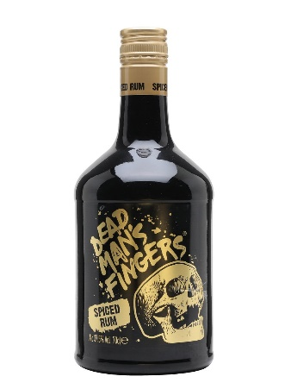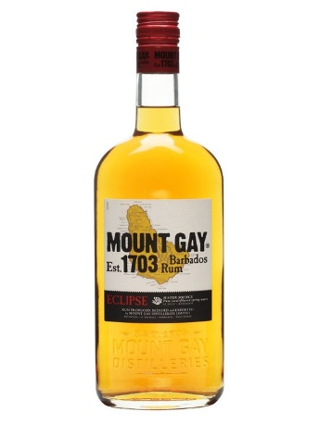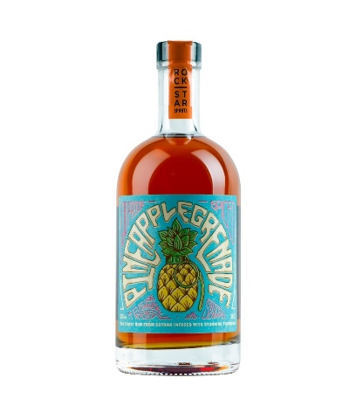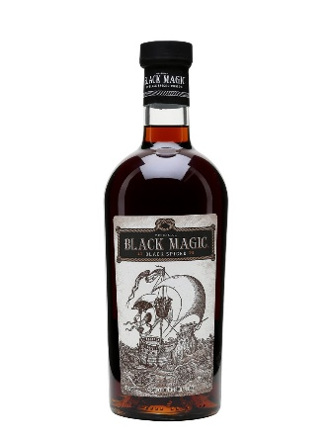

Description | ABV | Category | Quando Pricing £
Admiral Vernons – Old J Spiced Rum 70cl | 40 | Rum | £19.72
Admiral Vernons – Old J Spiced Cherry Rum 70cl | 35 | Rum | £21.59
Admiral Vernons – Old J Spiced Gold Rum 70cl | 40 | Rum | £21.39
Admiral Vernons - Old J Spiced Silver Rum 70cl | 35 | Rum | £19.39
Admiral Vernons – Old J Tiki Fire Spiced Rum 70cl | 75.5 | Rum | £36.85
Bacardi Rum 70cl | 37.5 | Rum | £15.69
Bacardi Rum 1.5L | 37.5 | Rum | £31.86
Bacardi Oakheart rum 70cl | 35 | Rum | £14.50
Bayou – Spiced Rum 70cl | 40 | Rum | £15.50
Bumbu Rum 70cl | 35 | Rum | £35.69
Captain Morgan Original (Dark) Rum 70cl | 40 | Rum | £16.23
Captain Morgan Original (Dark) Rum 1.5L | 40 | Rum | £34.32
Captain Morgan Spiced Rum 70cl | 35 | Rum | £16.12
Captain Morgan Spiced Rum 1.5L | 35 | Rum | £34.32
Captain Morgan Tiki Mango & Pineapple Rum 70cl | 25 | Rum | £15.49
Chairmans Reserve, Rum 70cl | 40 | Rum | £18.00
Chairmans White Rum 70cl | 43 | Rum | £18.00
Dead Mans Fingers Banana Rum 70cl | 37.5 | Rum | £19.57
Dead Mans Fingers Cherry Rum 70cl | 37.5 | Rum | £19.57
Dead Mans Fingers Coconut Rum 70cl | 37.5 | Rum | £19.57
Dead Mans Fingers Coffee Rum 70cl | 37.5 | Rum | £19.57
Dead Mans Fingers Mango Rum 70cl | 37.5 | Rum | £19.57
Dead Mans Fingers Passionfruit Rum 70cl | 37.5 | Rum | £19.57
Dead Mans Fingers Pineapple Rum 70cl | 37.5 | Rum | £19.57
Dead Mans Fingers Raspberry Rum 70cl | 37.5 | Rum | £19.57
Dead Man’s Fingers Spiced Rum 70cl | 37.5 | Rum | £19.57
Don Q – Gold Rum 70cl | 40 | Rum | £17.50
Elements 8 - República, Rum 70cl | 40 | Rum | £23.00
Goslings, Black Seal Rum 70cl | 40 | Rum | £21.21
Havana 3yo Rum 70cl | 40 | Rum | £18.54
Havana Club 7yo Rum 70cl | 40 | Rum | £20.94
Havana Club Rum - Anejo Especial 70cl | 40 | Rum | £16.26
Jamaica Cove Black - Ginger, Rum 70cl | 40 | Rum | £20.50
Jamaica Cove Black - Pineapple, Rum 70cl | 40 | Rum | £20.50
Kraken Black Spiced Rum 70cl | 40 | Rum | £21.48
Kraken Roast Coffee Rum 70cl | 40 | Rum | £22.30
Kraken Black Cherry Rum 70cl | 40 | Rum | £22.30
La Hechicera Rum 70cl | 40 | Rum | £32.00
Lambs Navy 70cl | 40 | Rum | £14.87
Lambs Navy 1.5L | 40 | Rum | £32.68
Lambs Spiced Rum | 30 | Rum | £13.55
Mount Gay Rum 70cl | 40 | Rum | £18.89
Naud - Ron Panama 15yo Rum 70cl | 41.3 | Rum | £27.00
Pineapple Grenade 65% Overproof 50cl | 65% | Rum | £22.00
Plantation – Pineapple Rum 70cl | 40 | Rum | £26.00
Plantation – Xaymaca Rum 70cl | 43 | Rum | £27.00
Rumbullion, Spiced Rum 70cl | 42.6 | Rum | £31.40
Santa Teresa – 1796 70cl | 40 | Rum | £39.00
Sailor Jerry, Rum 70cl | 40 | Rum | £16.80
Shack – Orange Rum 70cl | 40 | Rum | £29.00
St Abbs - Cask Silver (WHITE RUM) 70cl | 40 | Rum | £18.00
Steampunk - Voodoo Spiced Rum 70cl | 70 | Rum | £17.50

ITEMS IN GREEN TO SELL OFF (ONCE GONE THEY ARE GONE)

