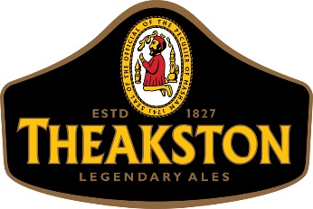
T&R Theakston Ltd
The Brewery,
Masham,
North Yorkshire,
HG4 4YD
6th October 2022

Dear Customer,
I write to inform you of an increase to our supply prices to you with effect from deliveries made on or after Monday 7th November 2022. The level of increase is shown in the attached schedule.
Like all businesses in the country, we have come under significant cost pressure throughout 2022. We have done our best to absorb those increases for as long as we can, but the acceleration in cost inflation over the 2nd half of this year means that we can no longer resist the financial pressures. Every cost increase we are receiving is significantly in excess of the level of this increase. Traditionally we have updated our supply prices annually, but we feel that with the current rate of cost inflation, we will be better to move prices more frequently but by a lower level, than one annual move at a higher level that our customers would find difficult to stomach.
We fully appreciate that you and your customers will be facing similar cost pressures so please be assured that this was not a decision we took lightly. Thank you in advance for your understanding and for your ongoing business with T&R Theakston.

Yours sincerely,
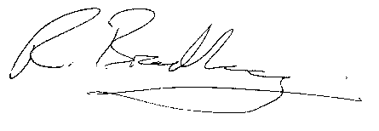
Richard Bradbury
Joint Managing Director

