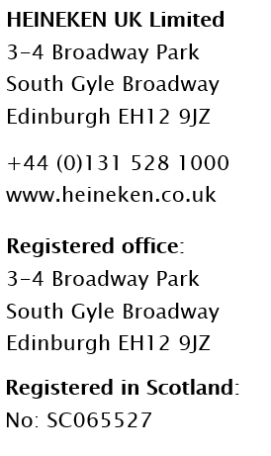

14th November 2022

Dear Customer

Wholesale selling prices for HEINEKEN beer and cider brands

I am writing to inform you of changes to the wholesale selling prices of our beer and cider brands, effective on all deliveries from Monday 16th January 2023.
Like many UK manufacturers, HEINEKEN UK is facing unprecedented cost increases on a number of critical inputs used to make and distribute Beer and Cider. This is predominantly driven by the significant rise in energy prices, which is also having a dramatic impact on the costs of other goods including glass, aluminium and malted barley.
We are continually looking at ways to mitigate cost volatility and throughout the year we have taken a number of steps to drive greater efficiencies in our business. However, due to the scale of recent and ongoing input cost increases, it is necessary to change the price of our products.
As a result, we will be increasing our wholesale selling prices by an average of 15.8%. The exact percentage per product is set out in the attached schedule. This increase will be duty exclusive.
At present, keg surcharges on existing SKU will remain unchanged, and have been static since 2016. However, new keg surcharges will be introduced on Birra Moretti as follows:
- £1.20 per 50 litre kegs; and
- £0.84 per 30 litre kegs.
The new Birra Moretti keg surcharges will be effective on all deliveries from Monday 16th January 2023.
Acknowledging the consumer trends towards lower strength products, we have also taken the decision to reformulate our Foster’s brand resulting in the ABV changing from 4% to 3.7%. This is also in line with our commitment to promote moderate consumption among alcohol drinkers. This change will apply to the new Foster’s Keg sku’s, which will be in circulation from 23rd January 2023, and the new packaged Foster’s sku’s, which will be in circulation from 13th February 2023.
The contents of this letter are confidential between HEINEKEN UK and you and it is not for onward distribution.

I want to take this opportunity to thank you for your continued support in these extremely difficult times. We appreciate your business and look forward to working with you in 2023. If you have any queries, please do not hesitate to speak to your usual HEINEKEN UK sales contact.

Yours sincerely,

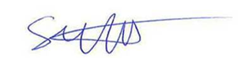
STEPHEN WATT
UK On Trade Director

